**Exp 1**

Aryaman Gautam

J001

*Aim*: Interfacing with Arduino uno

*Objective*:

1. Understand and implement connections between sensor and actuator with the microcontroller
2. Turn on the LED INBUILT
3. Turn on the LED EXTERNAL

*Architecture*:



Code:

/*

Q. Traffic signal with red, green, yellow LED. turn on red LED for 2sec, blink yellow 5 times with 0.5sec ON and 0.5 sec OFF then turn on green for 5 secs.

*/

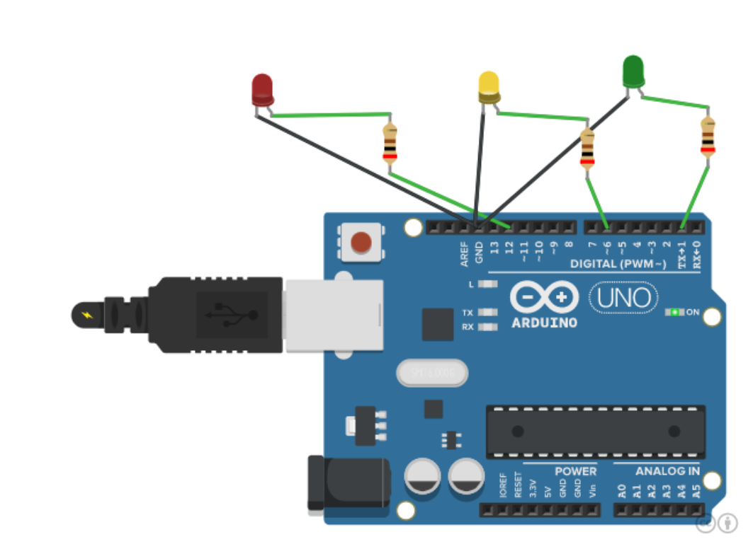

void setup()

{

pinMode(12,OUTPUT);

pinMode(6,OUTPUT);

pinMode(1,OUTPUT);

}

void loop()

{

digitalWrite(12,HIGH);

delay(2000);

digitalWrite(12,LOW);

for(int i = 1; i<=5;i++)

{

digitalWrite(6,HIGH);

delay(500);

digitalWrite(6,LOW);

delay(500);

}

digitalWrite(1,HIGH);

delay(5000);

digitalWrite(1,LOW);

}